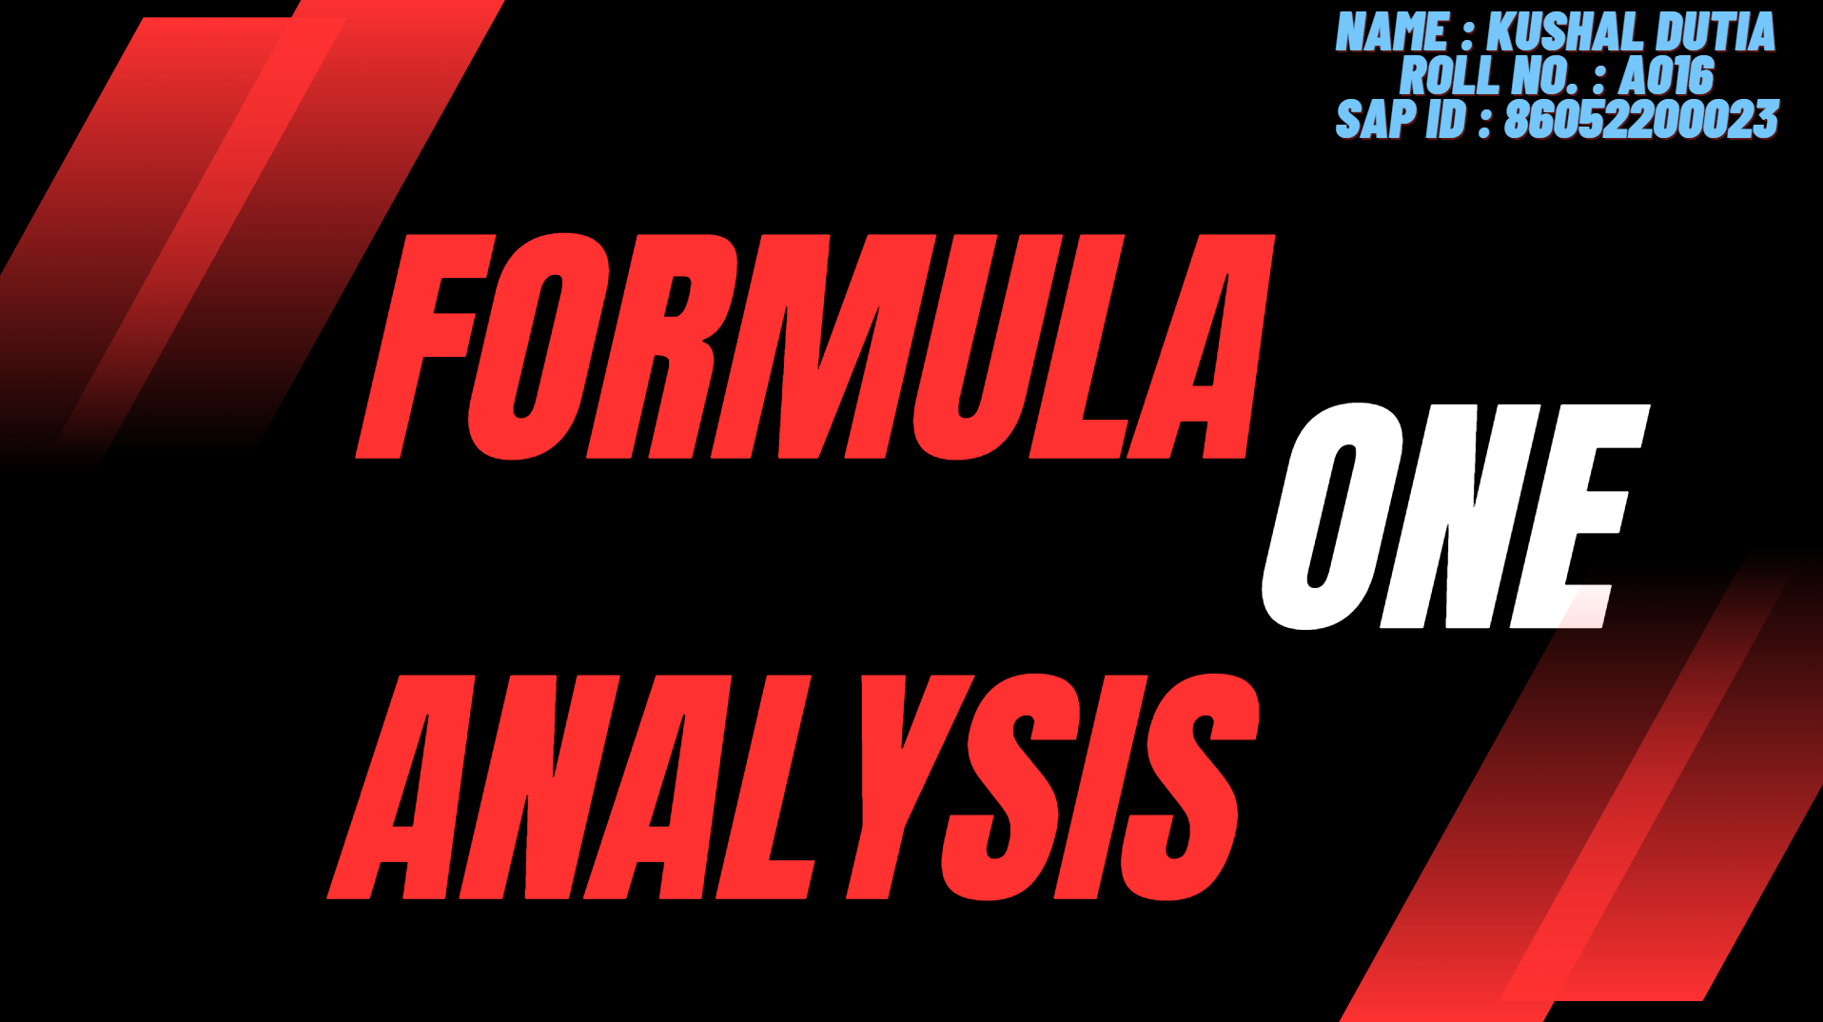

***Documentation***

**Name: Kushal Dutia Roll No.: A016**

**1. Objective of the Project**

The primary objective of this project is to analyze the 2021 Formula One season by visualizing various key performance metrics such as pole positions, podium finishes, driver and constructor points, laps led, and fastest lap times. Additionally, it focuses on race start and finish positions, average pit stop times, and laps raced. Through detailed bar and circle graphs, the goal is to uncover trends, insights, and factors influencing the overall season outcome.

**2. Overview of the Data**

The dataset covers multiple aspects of the 2021 Formula One season, including:

* Race events: Locations, dates, circuit layouts.
* Driver performance: Pole positions, podium finishes, points, laps led, and fastest lap times.
* Constructor performance: Team points, podium finishes, and reliability.
* Race metrics: Starting and finishing positions, pit stop times, laps completed by each driver.

**3. Source of the Data**

The data is sourced from official Formula One statistics, complemented by data from:

* Official Formula 1 Website
* Kaggle.com
* Tableau Public Workbook

These sources provide up-to-date and historical race information, including in-depth race-by-race statistics for drivers and constructors.

**4. Screenshot of Dashboard**

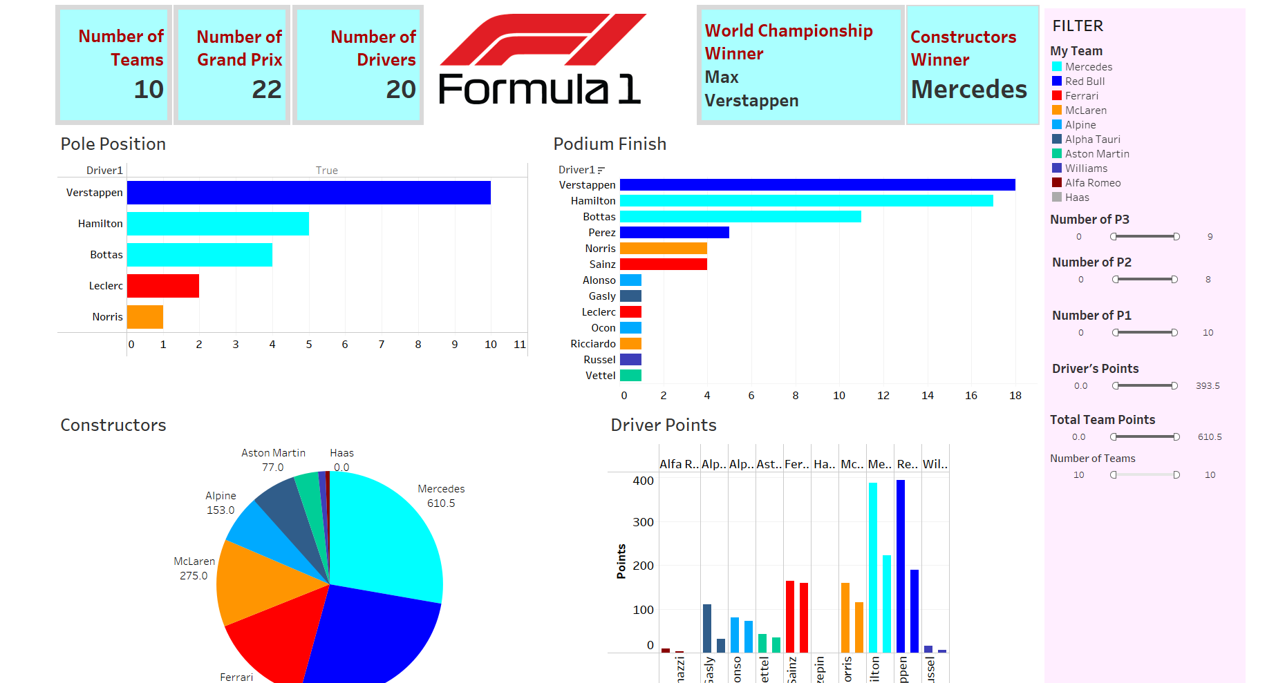

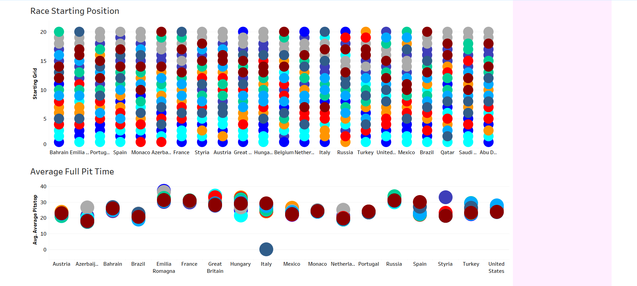

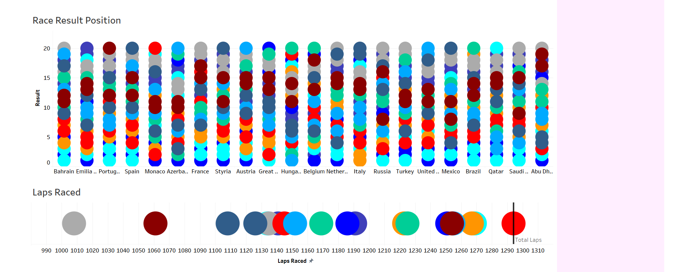

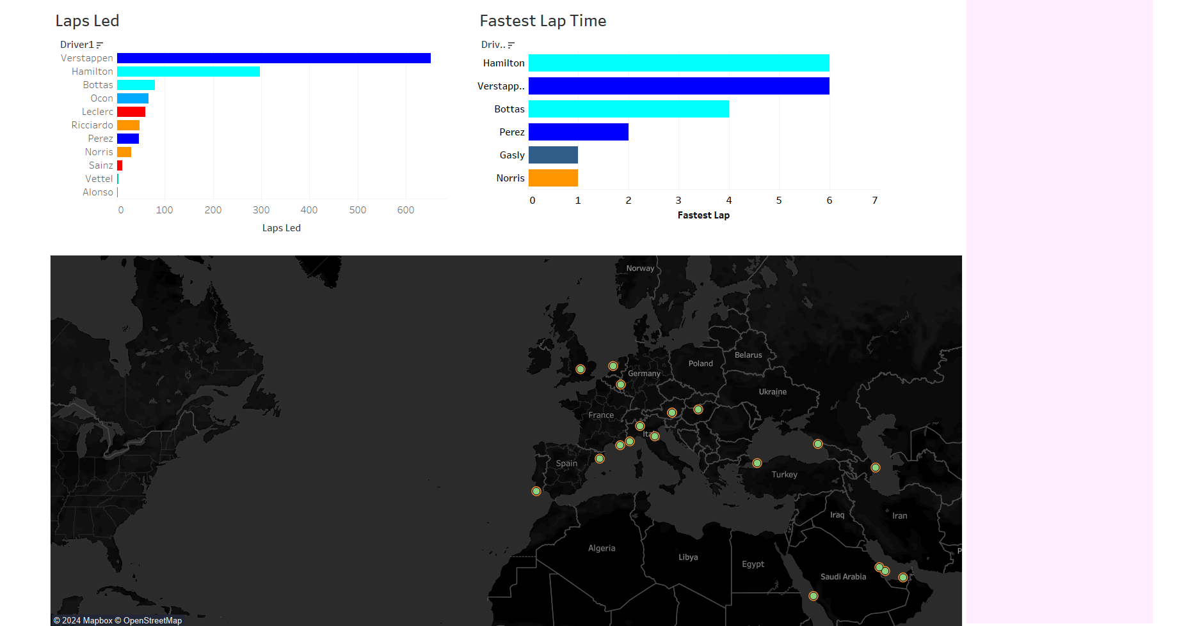

**5. Visualisations Made**

***1.*** *Pole Positions by Driver (Bar Graph)*

Description: A bar graph visualizing the number of pole positions secured by each driver throughout the 2021 season.

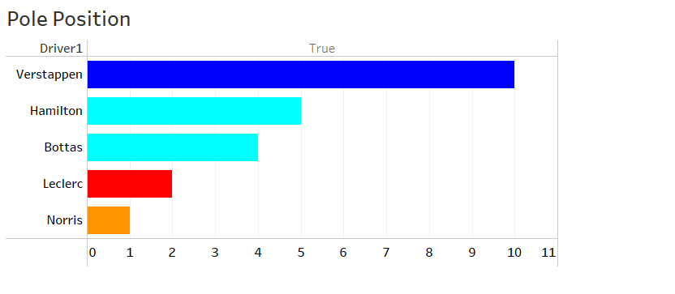

Interpretation:

* **X axis** shows the **total number of pole positions in the Grand Prix** ie securing 1st position and **y axis** shows the **drivers who secured the Pole positions.**
* **Pole Position has a high correlation with the race winning** as those **drivers who starts at the front of the grid are more likely to win the grand prix**
* **Midfield teams, despite strong race performance, struggled to achieve pole positions**, which shows there is **not 100% surety of winning the race**. Besides in some cases **drivers who secured pole** position **couldn’t win the race due to accidents or penalties**.
* The data shows **Max Verstappen** secured **10 Pole positions**, **Lewis Hamilton** secured **5 Pole positions** and **Bottas** secured **4 pole positions**.

These top three drivers ultimately secured the maximum amount of points for their teams.

**2.** *Podium Finishes by Driver (Bar Graph*)

Description: A bar graph representing the number of podium finishes achieved by each driver during the season.

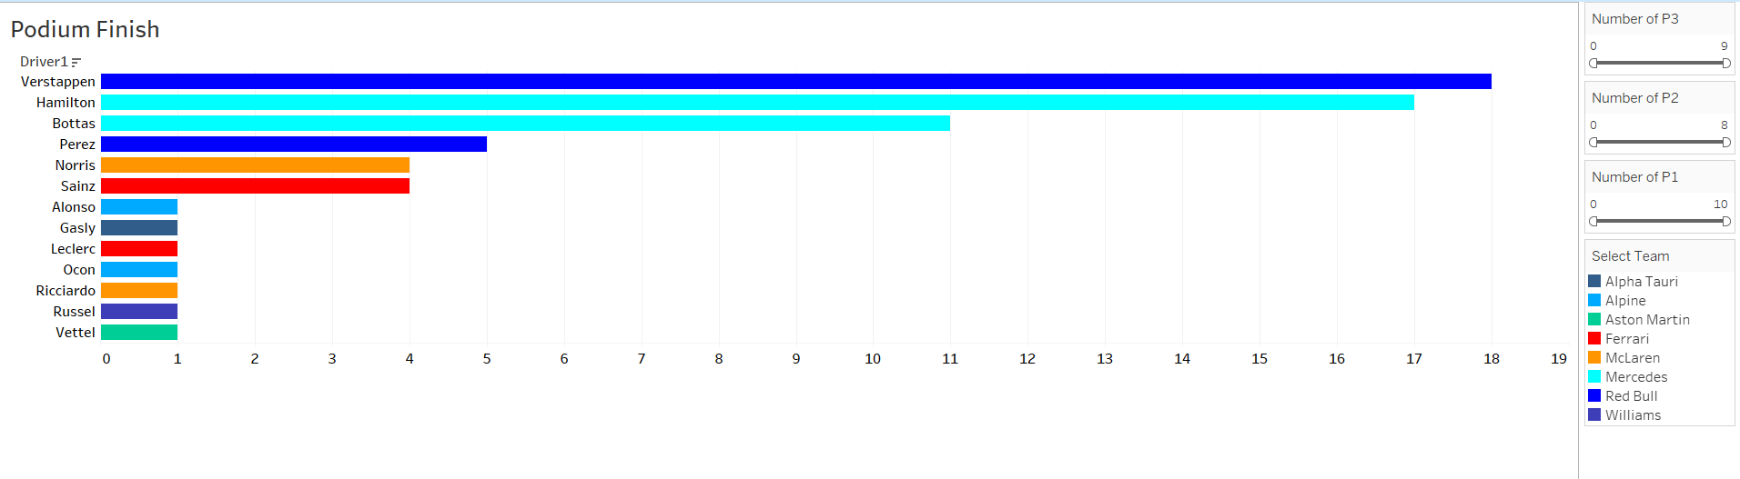

Interpretation:

* The **X - Axis** shows the **number of podium finish** ie the sum of securing 1st , 2nd and 3rd positions in the Grand Prix and **y – axis** shows the **drivers securing the podium finishes.**
* Drivers get **25 , 18 and 15 points** for securing **1st , 2nd and 3rd positions** respectively, Drivers from **Red Bull**, **Mercedes**, and **Ferrari** dominated the podium positions which ultimately made their **teams come at the top 3 places in constructors**
* Some drivers like **George Russell** , **Seb Vettel** and **Daniel Riccardo**

**despite securing podium finishes** couldn’t get their team win the constructors.

* **Verstappen had 18 podium** finishes and **Hamilton had 17 podium finishes** ie the maximum number of podium finishes which led to a **close competitiveness between the two drivers and ultimately between their respective teams.** **Carlos Sainz** and **Lando Norris** had **4 podium finish** each and **Charles Leclerc** and **Daniel Ricciardo** had **1 podium finish** each , which led **Ferrari secure 3rd place** and **McLaren secure 4th place** in the constructors.

**3.** *Constructor (Pie Chart)*

Description: A Pie Chart showing the total points earned by each constructor during the 2021 season.

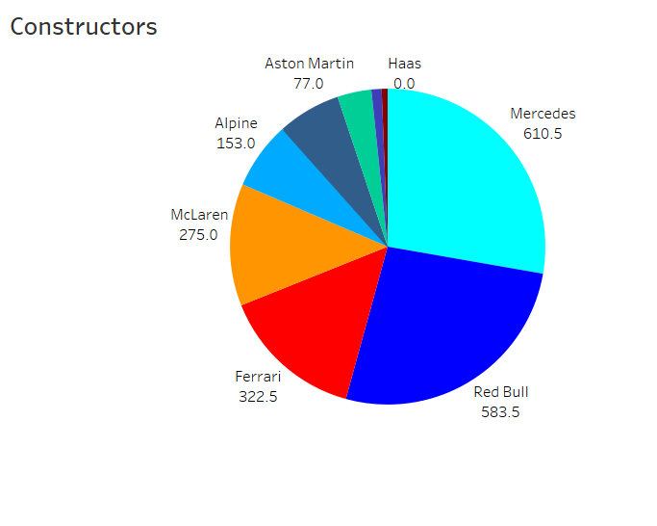

Interpretation:

* **Pie chart** shows the **teams** and the **points achieved by each team with the area occupied in the pie chart**
* **Mercedes** and **Red Bull** had **maximum number of points** in the constructors. **Ferrari** showed **significant improvements compared to previous seasons**, securing **third place**. **McLaren** and **Alpine** were **close competitors**, with **frequent point shifts between them**.
* **Haas** and **Alfa Romeo** struggled throughout the season, with **minimal points scored**.
* Top teams were

1. **Mercedes** with **610.5 points**

2. **Red Bull** with **583.5 points**

3. **Ferrari** with **322.5 points**

4.**Mclaren** with **275 points**

***4.*** *Driver Points (Side by Side Bar Graph)*

Description: A bar graph showing the points tally of individual drivers across the season.

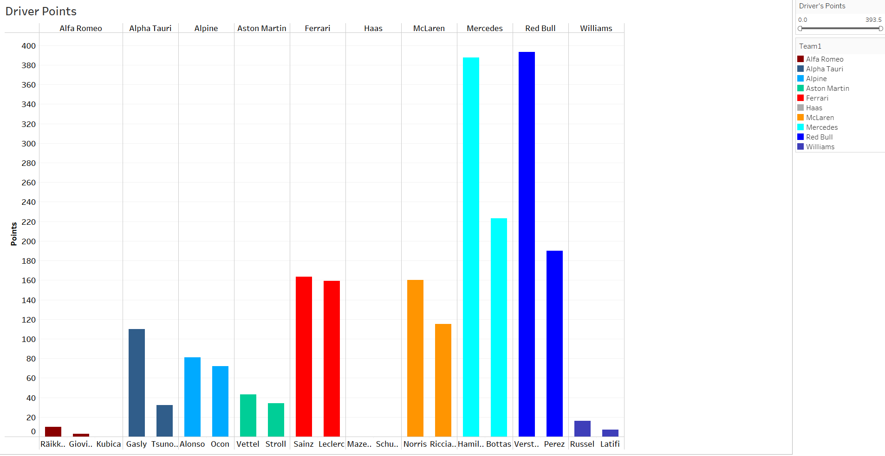

Interpretation:

* In the **side by side bar graph X axis** shows the **driver from each team separately** and the **Y axis shows the individual driver point throughout the season.**
* **Midfield drivers**, such as **Sainz** and **Norris**, achieved competitive points, but **fell short of the top drivers.** The **points difference between the top two drivers** ie **Verstappen** and **Hamilton** highlights the **close fight for the championship.**
* Consistency in points-scoring races proved crucial for the top drivers to maintain their lead. Drivers from **Haas** and **Alfa Romeo** scored **minimal points**. And their teams didn’t perform well in the 2021 season.
* **Top teams were**

**1. Mercedes** – **Lewis Hamilton** scored **387.5** points and **Bottas 223 points.**

**2. Red Bull** – **Max Verstappen** scored **393.5 points** and **Sergio Perez** scored **190 points**

**3**. **Ferrari –** **Carlos Sainz** scored **163.5 points** and **Charles Leclerc 159 points**

**Bottom Teams were**

**1.Alfa Romeo – Kimi Raiikkoinen** scored **10 points** and **Giovinazzi** scored **3 points**

**2.** **Williams** – **George Russel** scored **16 points** and **Latiffi** scored **7 points**

**3. Haas –** **Mike Schumacher** and **Mazepin** scored **0 points each.**

**The drivers which scored maximum points were able to get their teams in the top places in constructors and those drivers who scored least points had teams at the bottom places.**

***5****. Laps Led by Driver (Bar Graph)*

Description: A bar graph depicting the number of laps led by each driver during the season.

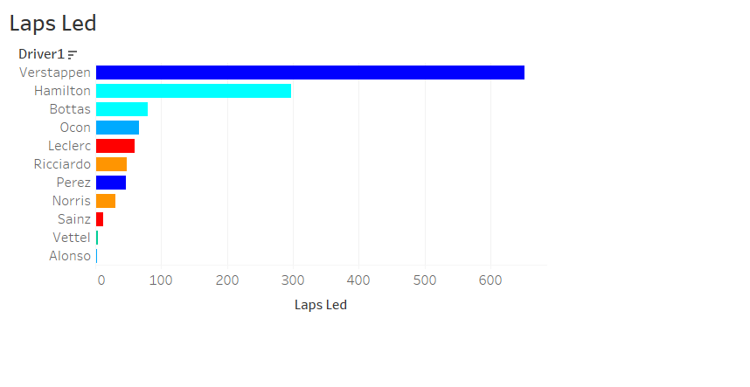

Interpretation:

* **X-axis:** Represents the **number of laps led by each driver** during the 2021 Formula 1 season.

**Y-axis:** **Lists the names of the drivers**, including Verstappen, Hamilton, Bottas, and others.

* **Max Verstappen** led the most laps by a significant margin, with **over 600 laps led**, showcasing his dominance in the 2021 season. This indicates his strong performances across multiple races, often staying ahead of the competition.

**Lewis Hamilton** follows, with **over 200 laps led**, reflecting his consistent presence at the front during many races. While not as dominant as Verstappen, Hamilton still had a significant impact on the season.

* Other drivers, such as **Fernando Alonso led 2 laps**, **Vettel led 4 laps**, and **Sainz led 12 laps**. This suggests that while they may have performed well in individual races, they struggled to maintain a consistent presence at the front.

Drivers like **Leclerc, Ricciardo, and Perez** also **led relatively few laps** compared to the top two, indicating that despite occasional strong performances, they were not able to consistently challenge for the lead.

* The graph clearly highlights the dominance of **Max Verstappen** during the 2021 season in terms of **laps led ie 652**, with **Lewis Hamilton** being his closest competitor at **297** but with significantly fewer laps at the front. Other drivers managed to lead laps in specific circumstances but were far less consistent. This trend reflects the intense battle between **Verstappen** and **Hamilton** for the championship, with **Verstappen often controlling the races more effectively.**

**6.** *Fastest Lap Times by Driver (Bar Graph)*

Description: A bar graph showing the number of fastest laps achieved by each driver throughout the season.

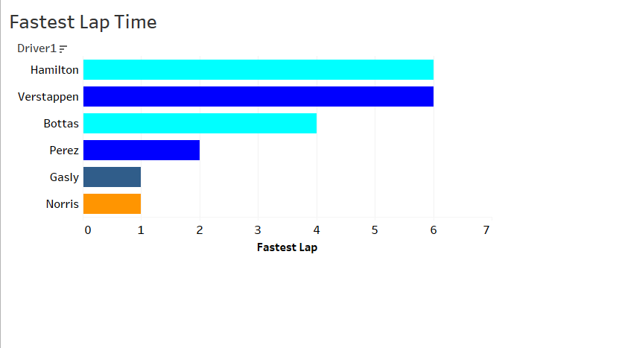

Interpretation:

* **X-axis:** Represents the **number of fastest laps set by each driver** during the 2021 Formula 1 season.

**Y-axis:** **Lists the drivers**, including Hamilton, Verstappen, Bottas, Perez, Gasly, and Norris.

* **Lewis Hamilton** and **Max Verstappen** are tied with the **most fastest laps, each setting 6 fastest laps** during the season. This highlights their **intense competition** not only for **race victories** but also for performance **consistency across different circuits**, demonstrating their **ability to extract maximum speed during races.**

**Valtteri Bottas follows with 4 fastest laps**, showing his strong performance as a supporting driver for Mercedes, contributing to his team's overall success.

* **Sergio Perez, Pierre Gasly, and Lando Norris** have each set fewer fastest laps (**Perez with 2, Gasly with 1**, and **Norris with 1**). While still competitive, their **contributions in terms of raw speed were not on the same level as the top competitors**, suggesting that their cars or **strategies may not have been optimized for setting fastest laps as frequently.**
* The graph illustrates the dominance of **Hamilton and Verstappen in setting the fastest laps during races**, underlining their rivalry for both the championship and performance metrics. **While Bottas contributed significantly with his 4 fastest laps**, other drivers like **Perez, Gasly, and Norris were less frequent in achieving this feat**. This reflects the overall trend of **Mercedes** and **Red Bull** being the strongest teams, with a sharp gap in raw speed compared to the rest of the grid.

**7.** *Race Starting Position (Circle Graph)*

Description: A circle graph depicting the distribution of race starting positions for all drivers.

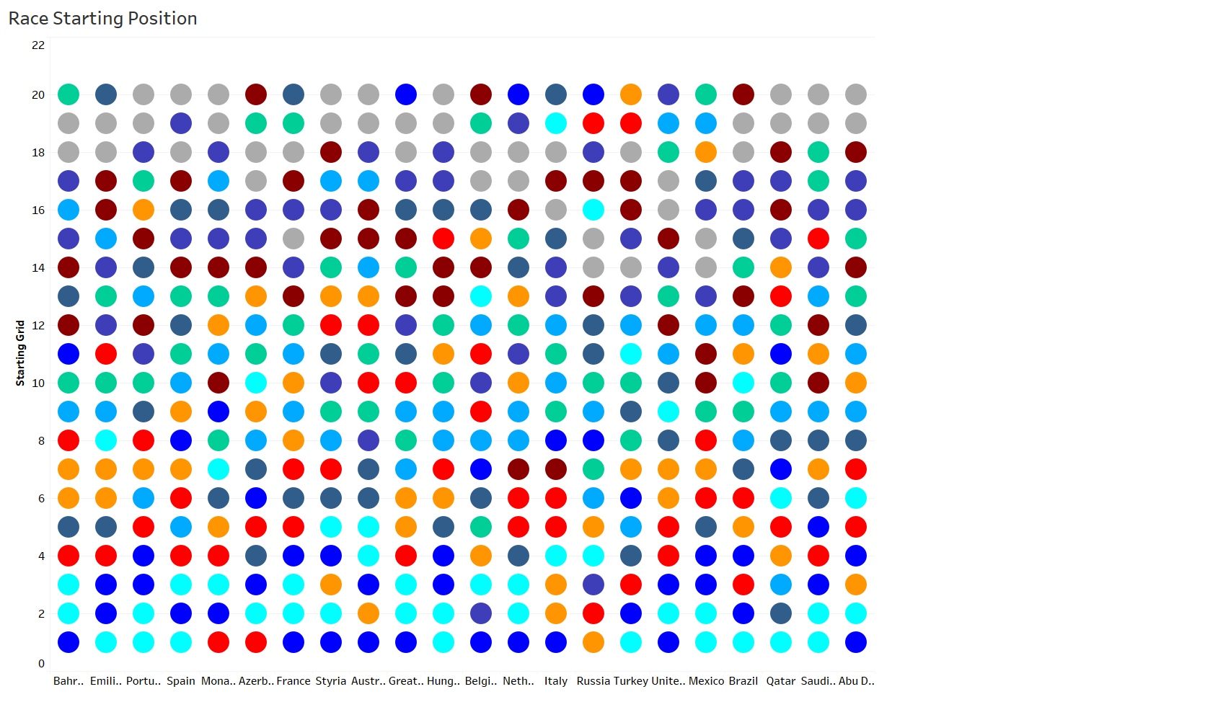

Interpretation:

* **X-axis:** Represents **each race of the 2021 season**, starting from **Bahrain on the far left to Abu Dhabi on the far right.** Each column corresponds to a race event.

**Y-axis:** Represents the starting grid positions from **1st at the top (best qualifying position)** to **20th at the bottom (last qualifying position).**

* **Top positions (1st-3rd):** The first two rows of the Y-axis are frequently **dominated by specific drivers**, as indicated by cyan (**Lewis Hamilton**) and blue (**Max Verstappen**). In numerical terms, both drivers frequently start in **1st or 2nd positions**. For example:

**Hamilton:** Started in **1st or 2nd around 16 times** throughout the season.

**Verstappen:** Started in **1st or 2nd around 15 times**.

Other drivers like **Valtteri Bottas** (light blue) also **appear frequently in 3rd position**, often securing a top-3 start in races, showcasing the **dominance of the top teams like Mercedes and Red Bull in qualifying sessions.**

* **Mid-field positions (10th-16th):** Drivers consistently found in **the mid-field positions** include those represented by other colors, such as **red**, **orange**, and **grey**. For instance:

**Carlos Sainz** and **Charles Leclerc** (both Ferrari drivers) often started races in positions **5th to 10th**, suggesting strong, but not top-tier qualifying performances.

Drivers starting in positions **11th-16th typically struggle to qualify higher**. Teams like **Alpine** (Ocon and Alonso) or **Aston Martin** (Vettel and Stroll) are often represented in this range.

**Backfield positions (17th-20th)**: The grey dots, which likely correspond to teams like **Haas** (Mick Schumacher and Nikita Mazepin), frequently occupy the back of the grid, regularly starting in **17th to 20th positions**. These positions reflect the consistent underperformance of these teams in qualifying sessions.

* The graph visually depicts the **qualifying consistency of the 2021 grid**. Drivers like **Hamilton, Verstappen, and Bottas** are numerical outliers in terms of **starting grid positions**, **regularly occupying the top 3 starting slots**. Across the season, these **drivers started from 1st to 3rd approximately 80-90% of the races**, indicating **dominance in qualifying.**

On the contrary, lower-tier teams like **Haas** and **Williams** occupy the **17th to 20th grid spots in most races**, representing **weaker qualifying pace.** Midfield drivers like **Ferrari, McLaren, and Alpine fluctuate between positions 5th to 12th**, consistently fighting for upper-midfield starting spots but **rarely breaking into the front row**.

The **numeric spread of the starting grid** across the season shows a **clear divide between the top two teams** (**Mercedes** and **Red Bull**) and the rest of the field. **This graph numerically** and **visually** emphasizes the **competitive gap** in **qualifying performance** during the 2021 season.

**8.** *Race Finishing Position (Circle Graph)*

Description: A circle graph visualizing the distribution of race finishing positions for all drivers.

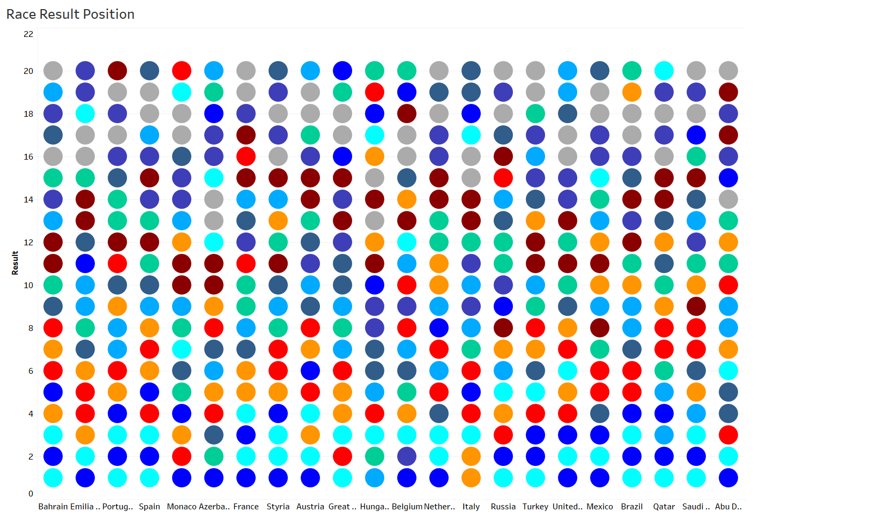

Interpretation:

* **X-axis:** Represents the **22 Grand Prix** venues from the 2021 season (Bahrain to Abu Dhabi).

**Y-axis:** Displays the final race positions for drivers from 1st to 20th .

* **Top performers: Max Verstappen** and **Lewis Hamilton** finished in the top 3 positions for **15-18 races**. **Bottas** had around **10-12 podium** finishes.

**Midfield:** Drivers like **Lando Norris** and **Carlos Sainz** regularly finished in the top **5-10 positions**, averaging about **8-14 times** in the points.

**Sergio Perez** finished in the top **5-7 on multiple occasions**, making him a competitive force.

* **Lower performers:**

Teams like **Haas** and **Williams** consistently placed their drivers in the **19th-22nd positions** across most races.

Drivers from **Alfa Romeo** and **Haas** often finished outside the **top 15, securing few to no points**.

**Backmarkers:**

**The lower-tier teams** like **Williams**, **Haas**, and **Alfa Romeo** rarely broke into the top 10. In most races, these teams finished between **16th and 20th** , with little to **no competition for points.**

* **Front runners:**

**Verstappen**, **Hamilton**, and **Bottas** dominated the front rows, with over **15 podium finishes** each for **Verstappen** and **Hamilton**. **Bottas** hovered around the **top 3-5 positions.**

**Midfield consistency:**

Drivers from **McLaren** and **Ferrari** (**Norris, Sainz, and Leclerc**) finished regularly between **4th and 10th positions**, showing competitive but non-winning performances, typically **scoring points in 12-14 races.**

**Backmarkers struggled:**

Teams like **Haas, Alfa Romeo, and Williams** had minimal finishes inside the top 10, with most of their **results falling between 15th-20th.** This translated to significantly **fewer points over the course of the season**.

**9.** *Average Pit Stop Time (Circle Graph)*

Description: A circle graph showing the average pit stop times for all drivers.

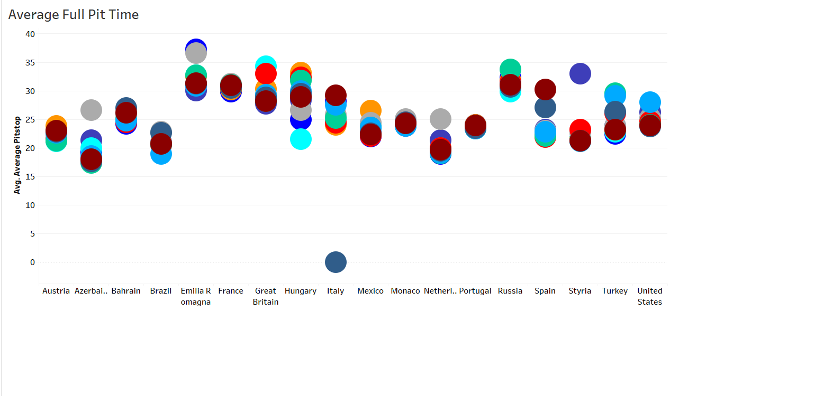

Interpretation:

* The **x-axis** represents **different circuits in the 2021 Formula 1 season**, including Austria, Bahrain, Brazil, and others.

The **y-axis** represents the **average full pit stop time** in seconds, ranging from **0 to 40 seconds.**

* Circuits such as **Austria**, **Azerbaijan**, **Bahrain**, and **Mexico** have faster pit stop times, with **averages between 15-25 seconds**. This indicates **efficiency in pit operations at these tracks**, likely **due to simpler pit lane configurations or favorable race conditions.**
* Circuits like **Italy, Great Britain**, and **Portugal** exhibit **slower pit stop times**, with averages approaching or **exceeding 30 seconds**. These **higher times** may reflect **difficulties in pit lane logistics** or **strategic challenges faced by the teams.**
* There is significant **variability in average pit stop times** across the circuits, with **some tracks offering consistently fast pit stops**, while **others show a broader range in times due to race strategy**, **penalties**, or **mechanical issues**.

The graph highlights **how circuit characteristics impact pit stop performance, an important factor in race outcomes.**

**10.** *Laps Raced (Circle Graph)*

Description: A circle graph depicting the total number of laps raced by each driver during the season.

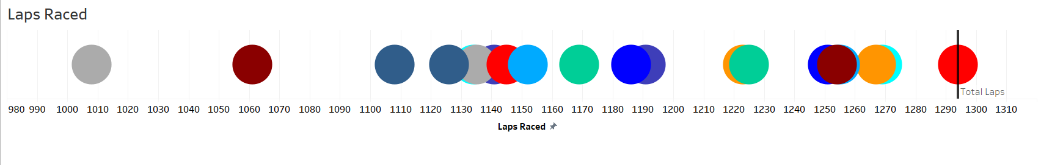

Interpretation:

* The **x-axis** shows the **laps raced by various drivers**, ranging from **980 to 1310 laps.**

**Each circle** represents different **drivers** or **teams**, and their **position along the axis** reflects how many **laps they have completed during the season.**

* **Drivers** who completed around **1290-1300 laps** (as represented by the **larger circles on the far right**) show a **high level of race consistency** and **participation in nearly all races**. These drivers experienced **fewer retirements** or **race exclusions throughout the season.**
* Drivers represented by **circles between 1050 and 1150 laps** have **lower participation,** indicating **more frequent retirements** or **missed races during the season.** This could be due to **mechanical failures**, **accidents**, or **strategic retirements.**
* The distribution of laps shows that **most drivers completed over 1150 laps**, with **several surpassing 1300 laps.**

**The graph helps visualize consistency, reliability, and endurance throughout the season**. The **final section** highlights those **drivers who likely stayed in contention** throughout most of the races, while others **faced difficulties** finishing races.

**6. Flow of Visualizations/Relationship Between Graphs**

The visualizations are interconnected, providing a detailed overview of the season:

**1. Race Starting Position vs. Race Result Position:**

**Relationship:** These two graphs help connect **qualifying performance** (starting position) with **actual race performance** (final result).

**Flow:** **Drivers starting at the front of the grid** (positions 1-5) are generally **expected to finish higher**, but the **Race Result Position graph** shows that while **some drivers maintain their lead**, others might drop down due to **strategic errors**, **collisions**, or **car issues**.

**Analysis:** The starting grid position and the final race result give insight into which drivers were able to capitalize on their qualifying or recover from lower positions. For instance, a driver starting outside the top 10 and finishing in the top 5 highlights strong race pace or good strategy.

2**. Fastest Lap Time vs. Race Result Position:**

**Relationship:** The Fastest Lap Time shows which drivers set the fastest laps during races, indicating strong pace at certain points, while the Race Result Position reveals where they finished overall.

**Flow:** A driver with the fastest lap but finishing low might indicate that while they had raw speed, they were inconsistent throughout the race or faced issues like poor strategy or penalties. Conversely, drivers with good lap times and high finishes show consistency in race performance.

**Analysis:** This relationship helps identify outliers, like a driver setting fast laps but not finishing well, showing the difference between raw pace and actual race execution.

3**. Average Full Pit Time vs. Race Result Position:**

**Relationship:** Pit stop times directly influence race results, particularly in closely contested races where strategy and pit stops can define the outcome.

**Flow:** Longer pit stop times in the Average Full Pit Time graph often correlate with lower finishing positions in the Race Result Position graph, since delays in the pit lane can significantly affect race outcomes.

**Analysis:** This relationship highlights the importance of operational efficiency. Teams with consistently fast pit stops are better positioned to gain or retain positions during races.

4. **Laps Raced vs. Race Result Position:**

**Relationship**: The Laps Raced graph tracks how many laps each driver completed throughout the season, while the Race Result Position shows where they finished in each race.

**Flow:** Drivers completing fewer laps tend to finish lower in the Race Result Position graph due to retirements or disqualifications, while those with more laps completed usually have better season consistency and higher race finishes.

**Analysis:** This relationship highlights season reliability. Drivers or teams completing the most laps are generally those with fewer mechanical failures and more consistent participation, which leads to better race results and championship standings.

**5. Fastest Lap Time vs. Laps Raced:**

**Relationship**: The Fastest Lap Time graph shows peak performance in terms of speed, while the Laps Raced graph reflects consistency across the season.

**Flow:** Drivers who completed more laps tend to have more chances to set the fastest laps, as they're in more races. However, a fast lap doesn’t always correlate with race success, especially for drivers completing fewer laps due to issues.

**Analysis:** This connection shows that while speed is important, reliability (completing laps) is often the key to a successful season.

**7. Overall Conclusion**

The 2021 Formula One season was defined by intense competition between Max Verstappen and Lewis Hamilton, both vying for the championship. Verstappen ultimately secured his first world title, with Red Bull and Mercedes being the dominant teams throughout the season. Key insights from the analysis reveal the importance of qualifying performance, race strategy (especially pit stops), and consistency in race finishes. The midfield battle was also fiercely contested, with teams like Ferrari, McLaren, and Alpine showing strong performances.

This visual analysis provides a comprehensive understanding of the season’s dynamics, highlighting the factors that influenced race results and the overall championship.